RKT Diamond Drive Clutch Kit

1245 Industrial Park Rd.

Preston, ID 83263

208-852-3221 Fax 208-852-3228
email: torqueline@2strokeheads.com
www.2strokeheads.com

NOTE: Installation Pictures will be on the web-site October 2008

- Remove existing secondary spring by removing the cover, long plastic spacer, thin plastic spacer Under stock spring), and plastic nut. ’07 and newer models will not have the plastic nut. NONE of these parts will be re-installed!

- Purchase ANY CAT secondary torsion spring you wish.. We like the CAT Red/White (CAT part # 0648-114), Speedwerx Blue, or Cat Sno-Pro Green Spring Part # 0748-025. ANY spring can be used with proper primary weights.

- Remove the stock helix. To remove helix, we recommend using an impact driver (NOT AN AIR IMPACT RATCHET but a HAMMER driven impact driver that can be found at your local auto-parts store) with a T-20 Torx Head. It also helps to heat with a VERY DIRECTED SMALL flame on the helix where the bolts are threaded. CAT uses heavy loc-tite so these can be difficult to get loose. For ’07 and ’08 clutches, you will need to keep the helix under pressure and remove the 9 Torx head bolts located on back-side of the helix. Be careful, the spring is tensioned and when the helix is loosened, it can shoot off and cause injury. NOTE: There is a thin steel spacer washer that the stock , and RKT, helix rests upon. This OEM spacer has 9 holes in it (6 on the ’05 clutch). This spacer MUST be used/re-installed or clutch damage will occur.
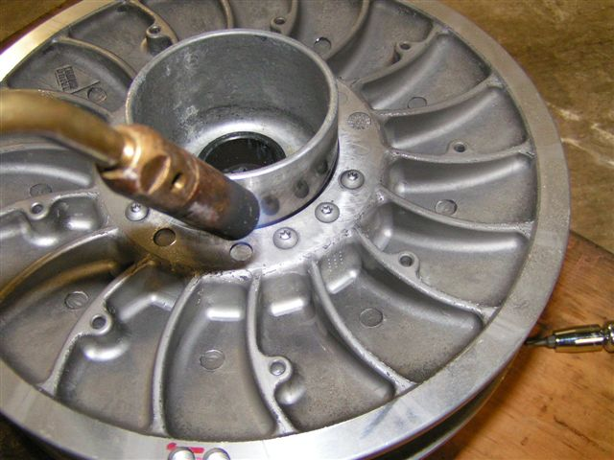

- Remove the 3 forward stock nylon rollers and install the 3 (supplied) hard rock rollers in their place. See addendum at the end of this document for 2009 models with Electronic Reverse.
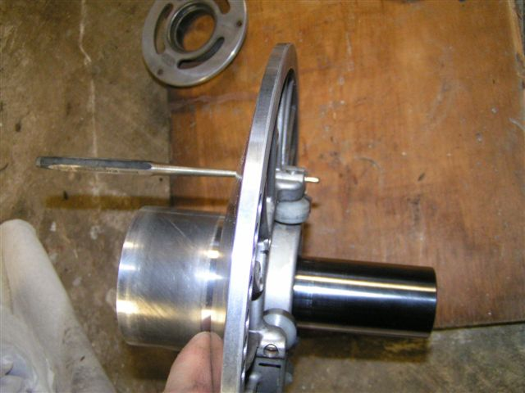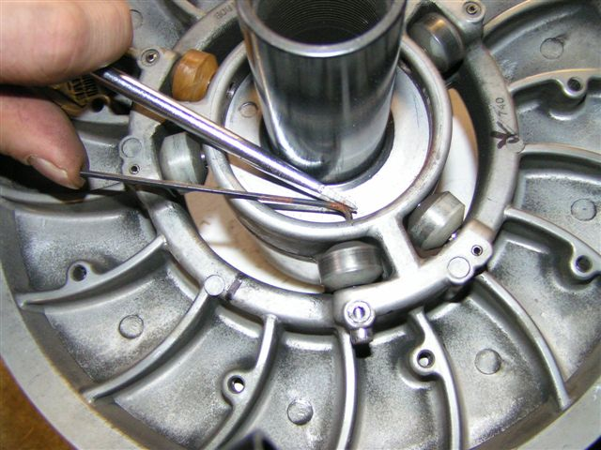

- Take the new RKT Helix and take note of the machined vertical line in the side of the helix. Install the new RK Tek Helix and put a few bolts in to hold it in place for a measurement. Do not fully tighten or install all bolts at this time.

- Take the entire clutch assembly and squeeze both sheaves together so they are touching (important).

- With the clutch sheaves held together (Step #5), take a sharpie pen and make a mark in the spring area at the bottom of the clutch. This mark should be inline with the machined line on the helix you noted in Step #4. This sharpie mark needs to be located at the outer-most portion of the clutch casting (near casting hump). This is the mark for the hole for the spring’s ear. Remove RKT Helix and set aside.

- Using a long .250” to .275” drill bit, drill a .300” to .350” deep hole at your mark. Drill the hole as straight as possible. Mark the location of this hole with a sharpie pen on the casted “hump” that you drilled next to.

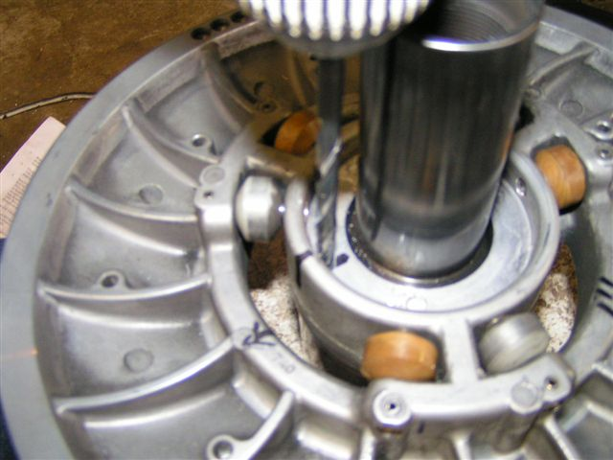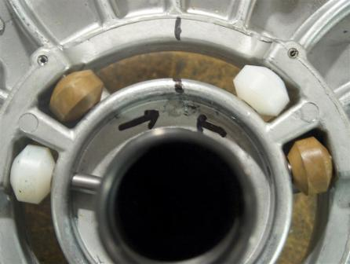

- Make sure the thin, steel, spacer washer (step #3) is installed.

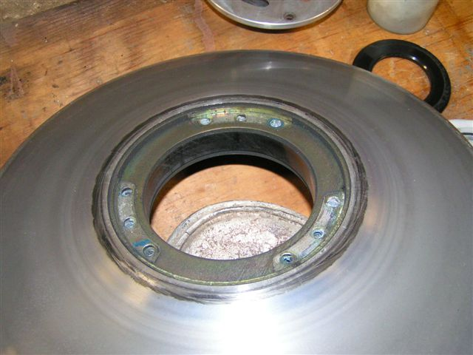

- Install the RKT Custom Helix using the 9 bolts (supplied). Loc-tite (BLUE) all 9 bolts. Make sure the drilled hole still is aligned with the line you drew in Step #4. Mark the tapped hole on top of the helix that coincides with the line on the helix.

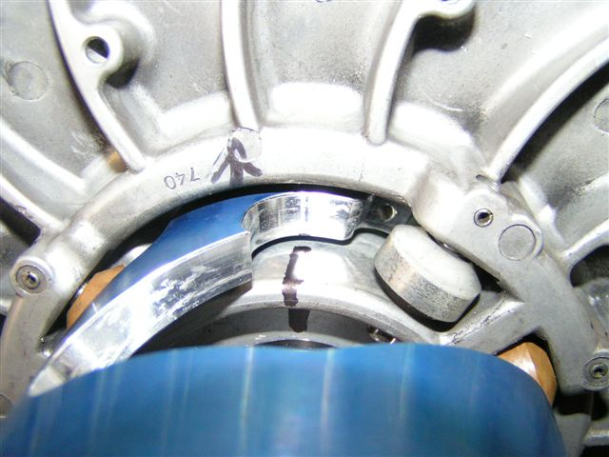

- Set the billet top cover onto billet helix. NOTE: This cover has 3 “arcs”. Each arc has 7 bolt positions. Line up the hole marked in step #10 with the left-most hole of ANY “Arc” in the billet cover. Now mark the remaining 2 helix holes that also line up with the left-most slot in the other 2 “arcs” of the billet cover. These will be the 3 holes where the bolts will be installed. Remove billet top cover.

- Slide on, over the shaft, the aluminum bottom carrier and line up its hole with your hole drilled in step #7.

- Install spring over shaft and place ear through bottom carrier into the drilled hole (Step #7).

- Place Billet Cover onto spring’s upper ear in the cover’s “left-most” drilled (not tapped) hole.

- While holding downward pressure, twist cover/spring, clockwise (about 10 degrees), until all three marked holes from step #11 are in each “arc’s’ left-most position. Make sure that the spring’s ear remains in the drilled hole when doing the twisting. While holding the tension on the spring, install all 3 (supplied) bolts through the top cover’s arcs into the marked holes (step 11) of the helix. Leave bolts loose.

- MAKE SURE that the mark you made in step #7 is still aligned with the bottom spring ear.

- Install the clutch onto the Diamond Drive.

- Install Black Diamond Quick Adjust Belt Deflection Adjuster (supplied). This adjuster is Left Hand Thread. So, turning it to the left is tight, right is loose. Do not use ANY washers behind this adjuster. Tightening the adjuster will push the sheaves open allowing the belt to rider lower in the secondary. This increases belt deflection. We recommend setting the belt deflection to about 1” with light pressure. If your belt is “squealing” at idle, you will need to turn the adjuster to the left until the squealing stops. If you get your deflection too loose, you will have a very “soft” low end. Try and set deflection to a point where the belt will just lightly squeal.

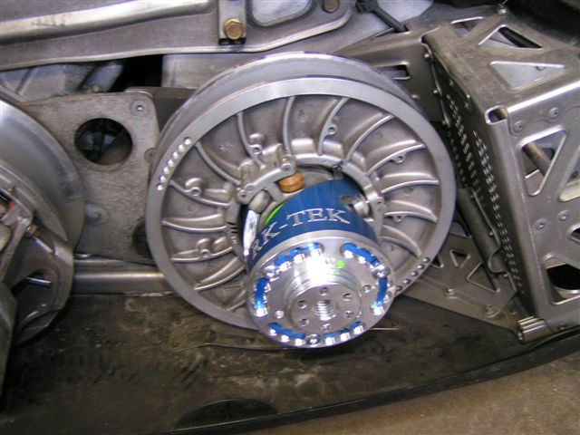

- Using the 3 prong tool (RKT or other) push in, with tool, on the billet cover and turn the cover clockwise until you reach the middle hole of each arc in the cover. Tighten all 3 bolts.

- Install supplied allen head bolt, with washer. Tighten bolt snuggly (Approx 21ft/lbs) against the belt deflection adjuster. This bolt holds you clutch on the shaft. Loosening this bolt is required to be able to turn the belt deflection adjuster.

- To adjust spring tension:

a) Loosen the allen head bolt holding the clutch to the Diamond Drive.
b) Remove Belt Deflection Adjuster (step 18)
c) Loosen all 3 cover bolts but do not remove.
d) Using a 3 prong tool, push in on cover and twist cover
NOTE: Turn clockwise to add tension (more RPM) and counter-clockwise to lessen tension (less RPM).
More Spring Tension equates to a slower up-shift and more side-belt pressure.
e) Tighten head cover bolts, re-install deflection adjuster, allen bolt, and ride.

Addendum for 2009 and newer Diamond Drive ONLY

Do this step after step #3 in instructions

- Remove “Back-Shift” rollers (3) and replace with supplied RK Tek Billet pieces. Use the existing dowel pins and roll pins for the installation of the RK Tek billet pieces. Install billet pieces with “hook” facing towards the helix ramp.

- Make sure, before you install spring, that the rollers and the RK Tek Billet pieces clear the helix. Test this via rolling through entire shift range of the clutch by hand. Make sure the rollers are rolling on the helix.

- In order for reverse to work 100% of the time, don not run the SNO PRO green spring in the middle hole or any hole tighter. If using a softer spring, you can run a tighter hole position.

